Inventory/POS (Point of Sale) application from start to finish. let’s break it down step by step, so we end up with a real app that can be extend or deployed.
We’ll keep it WPF + .NET + MVVM, since it’s great for desktop inventory/POS systems.
1️⃣ Requirements & Features
Core features:
- Inventory management
  - Add/edit/delete products
  - Product ID, name, price, stock quantity
- Sales/POS
  - Add products to a cart
  - Checkout (reduce stock)
  - Calculate total, taxes, and change
- Reporting
  - View daily sales
  - View stock levels
- Persistence
  - Save inventory and sales to JSON (later DB if desired)
Nice-to-have:
- Categories for products
- Discounts
- Barcode support
- Receipt printing
2️⃣ Technology Stack
- Framework: .NET 8
- UI: WPF (desktop-friendly)
- Pattern: MVVM
- Data storage: JSON files (can switch to SQLite later)
- IDE: Visual Studio

3️⃣ Project Setup
Folder structure:
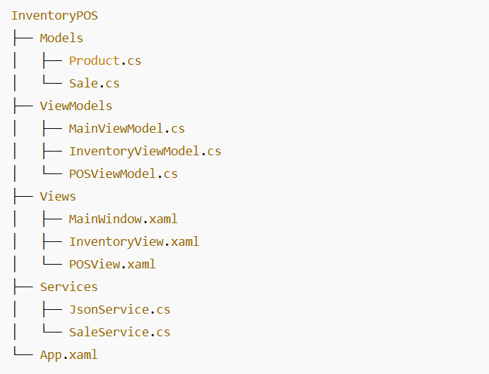

4️⃣ Domain Models (Business Data)
Product class
Sale class

5️⃣ MVVM & Logic
ViewModels
- InventoryViewModel: Manage products
  - Commands: Add, Edit, Delete
- POSViewModel: Manage cart & checkout
  - Commands: AddToCart, RemoveFromCart, Checkout
ObservableCollection for UI binding.

6️⃣ UI Design
InventoryView.xaml
- DataGrid → show products
- Buttons → Add/Edit/Delete
- Input fields → Product Name, Price, Stock
POSView.xaml
- ListBox → Cart items
- ComboBox/DataGrid → Products
- Buttons → Add to cart, Checkout
- TextBlock → Total price
7️⃣ Persistence (JSON)
JsonService class

8️⃣ Application Lifecycle
- Startup
  - Load products and sales from JSON
  - Populate UI
- Runtime
  - User adds products, edits stock
  - POS handles checkout → stock updated → sale recorded
  - UI updates automatically via MVVM
- Shutdown
  - Save inventory and sales to JSON

9️⃣ Testing & Improvements
- Ensure stock can’t go negative
- Validate inputs (price > 0, quantity >= 0)
- Improve UI responsiveness
- Add reporting filters
10️⃣ Future Steps
- Switch to SQLite or SQL Server
- Add user authentication (admin vs cashier)
- Barcode scanning
- Receipt printing
- Cloud sync

